**PERFUME E - COMMERCE DATASET 2024**

NAME : BHARATHI KANNAN V

DATE OF SUBMITTED : 18-07-2024

|  |  |  |
| --- | --- | --- |
| **S.NO** | **TOPICS** | **PAGE NO** |
| 1 | AIM OF THE PROJECT | 1 |
| 2 | PROBLEM STATEMENT | 1 |
| 3 | PROJECT DESCRIPTION | 2 |
| 4 | FUNCTIONALITICS | 5 |
| 5 | CODE IMPLEMENTATION DESCRIPTION | 6 - 12 |
| 6 | CONCLUSION | 12 |

**INDEX**

**1. Aim of the Project:**

The aim of a project in a perfume e-commerce dataset for a data analyst in 2024 could be to utilize data-driven insights to enhance various aspects of the e-commerce platform. Here are some potential project aims:

1. **Customer Segmentation**: Analyze customer data to identify distinct customer segments based on demographics, purchase behavior, or preferences. This could help in targeted marketing strategies and personalized recommendations.
2. **Product Performance Analysis**: Evaluate the performance of different perfume products in terms of sales, customer reviews, and returns. Identify top-selling products and factors influencing their popularity.
3. **Market Basket Analysis**: Discover patterns in customer purchasing behavior, such as frequently bought together items. Use association rules to optimize product bundling or promotional strategies.

**2. Problem Statement:**

**Objective:**  
 Utilize data analytics to optimize e-commerce strategies and improve customer experience in perfume sales.

**Scope:**

* Analyze sales data, customer behavior, and product performance.
* Develop customer segments for targeted marketing.
* Implement or enhance a recommendation system.
* Evaluate marketing campaign effectiveness and ROI.

**Objectives:**  
 Drive business growth by leveraging insights to enhance customer engagement and operational efficiency.

**Objective:**  
Optimize e-commerce strategies and enhance customer experience in perfume sales through data analytics.

**3. Project Description:**

**Focus Areas:**

* Analyze sales data, customer behavior, and product performance.
* Develop customer segments for targeted marketing.
* Implement a recommendation system and optimize marketing campaigns.

**Methodology:**

* Data collection, cleansing, and preprocessing.
* Statistical analysis, machine learning modeling for insights.
* Visualization of findings through interactive dashboards.

**Deliverables:**

* Comprehensive analysis report with actionable insights.
* Interactive dashboards for stakeholders.

**Outcome:**  
Enhanced business decision-making and improved customer engagement in the perfume retail sector.

This concise project description outlines the key objectives, methodologies, and expected outcomes of the data analysis project in e-commerce perfume sales.

**4. Functionalities:**

• **Data Extraction and Collection:**

* **Tools/Libraries:** Pandas, BeautifulSoup, APIs
* **Tasks:** Fetching data from databases, CSV files, or web scraping for building datasets.

• **Data Cleaning and Preprocessing:**

* **Tools/Libraries:** Pandas, NumPy, Regular Expressions (Regex)
* **Tasks:** Handling missing data, removing duplicates, standardizing formats.

• **Exploratory Data Analysis (EDA):**

* **Tools/Libraries:** Pandas, Matplotlib, Seaborn
* **Tasks:** Visualizing data distributions, correlations, identifying patterns.

• **Customer Segmentation:**

* **Tools/Libraries:** Scikit-learn, Pandas
* **Tasks:** Segmenting customers based on demographics, behavior using clustering.

• **Product Performance Analysis:**

* **Tools/Libraries:** Pandas, Matplotlib, Seaborn
* **Tasks:** Analyzing sales trends, top-selling products, customer preferences.

• **Recommendation Systems:**

* **Tools/Libraries:** Scikit-learn, TensorFlow/Keras, Pandas
* **Tasks:** Building recommendation engines for personalized suggestions.

• **Predictive Modeling:**

* **Tools/Libraries:** Scikit-learn, TensorFlow/Keras, Pandas
* **Tasks:** Developing models for sales prediction, customer churn, CLV estimation.

• **Marketing Campaign Analysis:**

* **Tools/Libraries:** Pandas, Matplotlib, Seaborn
* **Tasks:** Evaluating campaign effectiveness, ROI, customer acquisition metrics.

• **Visualization and Reporting:**

* **Tools/Libraries:** Matplotlib, Seaborn, Plotly, Jupyter Notebooks
* **Tasks:** Creating visual dashboards, reports to present insights.

• **Integration and Deployment:**

* **Tools/Libraries:** Flask, Django, Docker
* **Tasks:** Integrating analysis into web apps, deploying models for real-time insights

**6. Code Implementation:**

Step 1: Import Libraries

First, import necessary libraries such as Pandas for data manipulation and Matplotlib for data visualization.

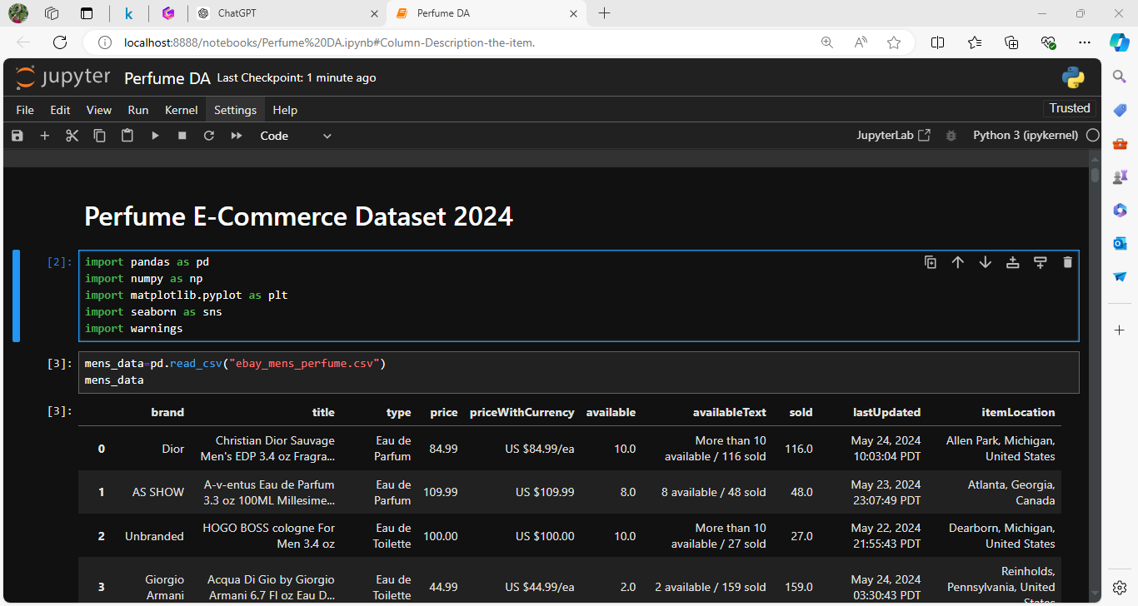

Step 2: Load the Dataset

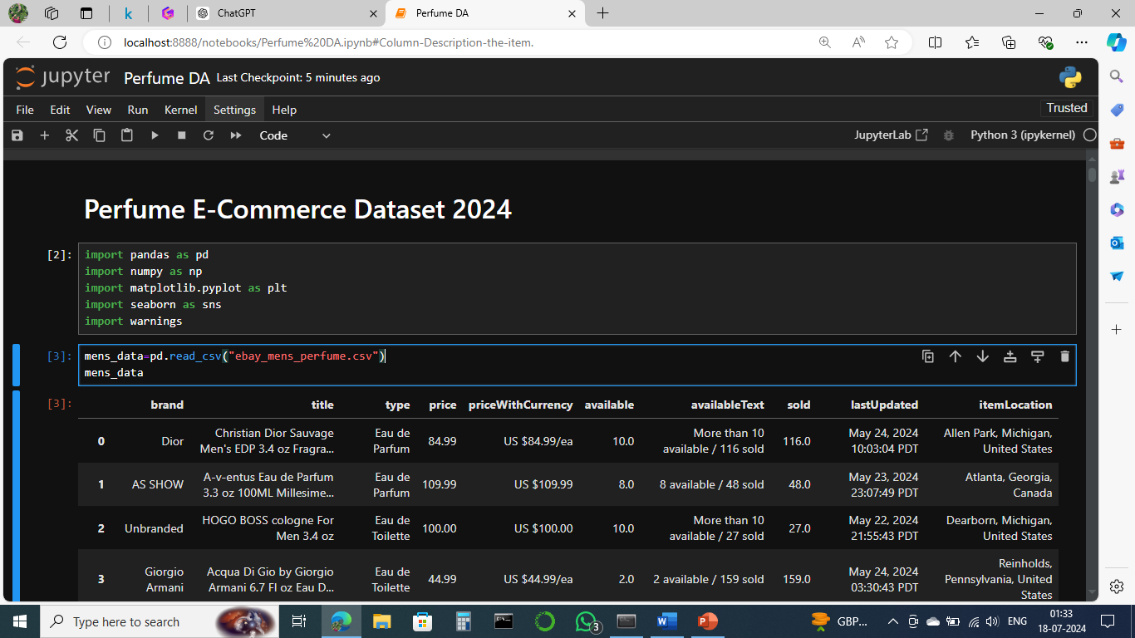

Step 3: Drop the column

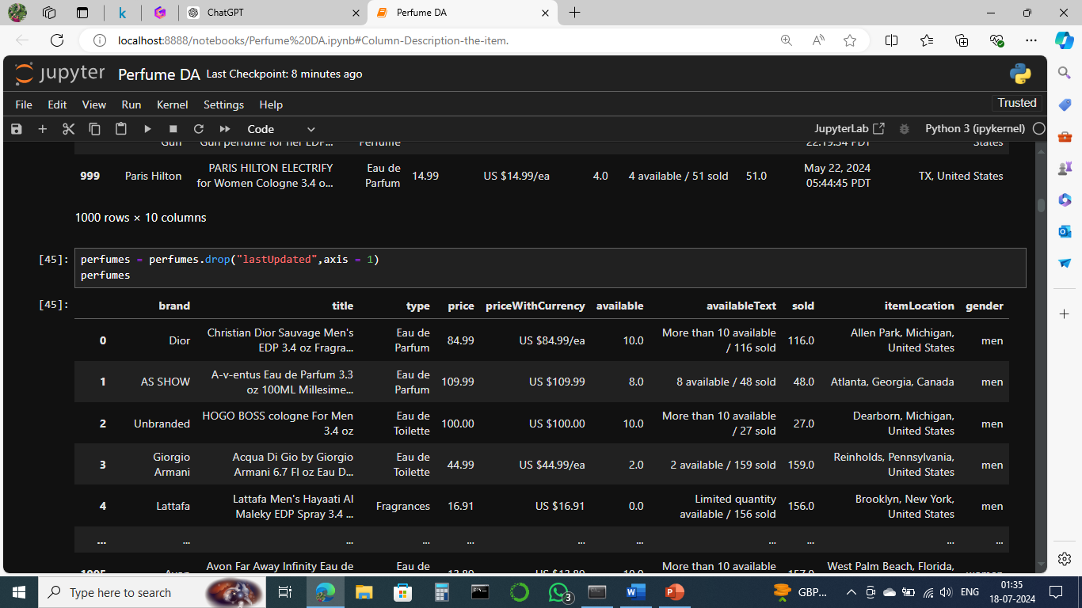

Step 4: Combine the dataset and add a gender column

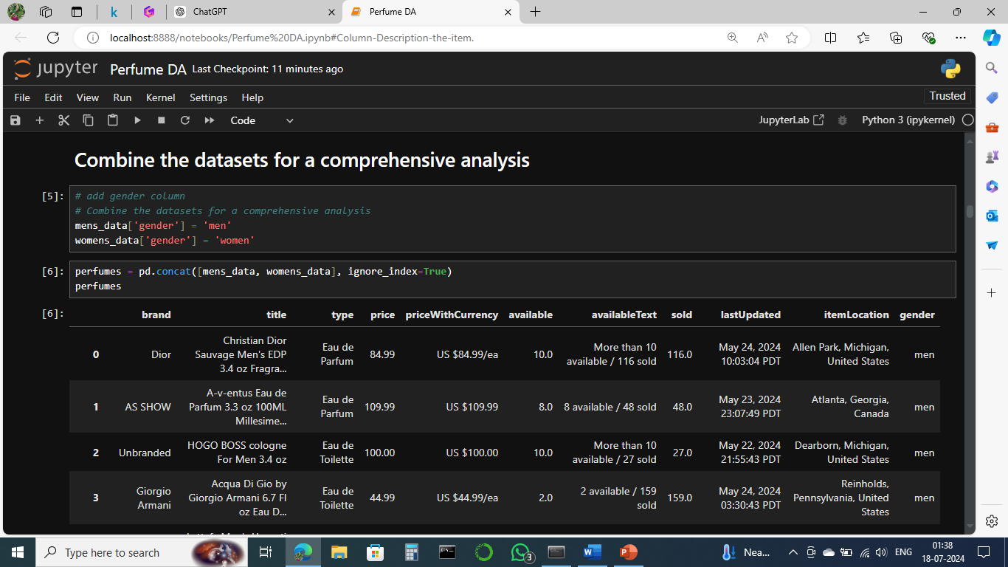

Step 5: Column description

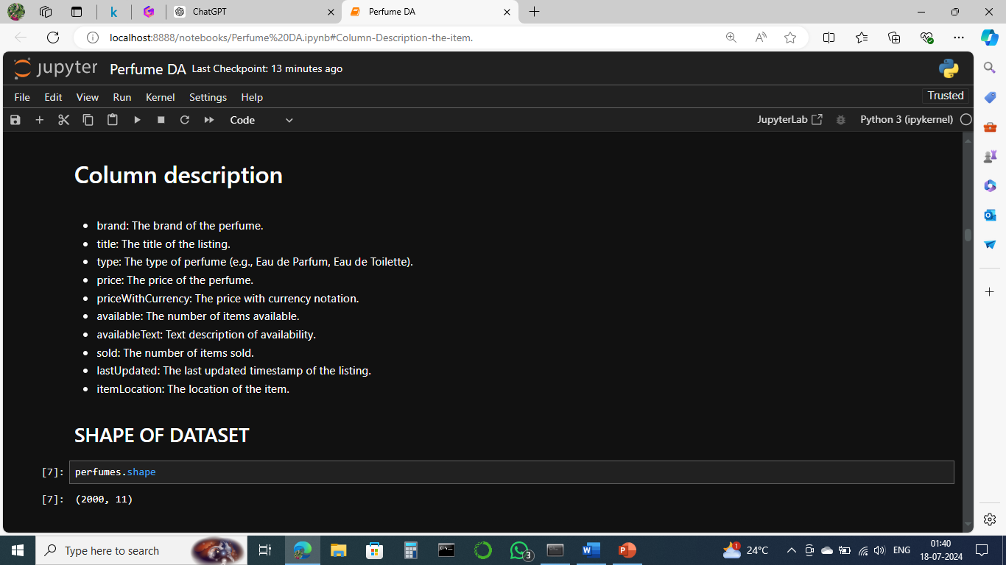

Step 6: Shape of dataset and check missing values:

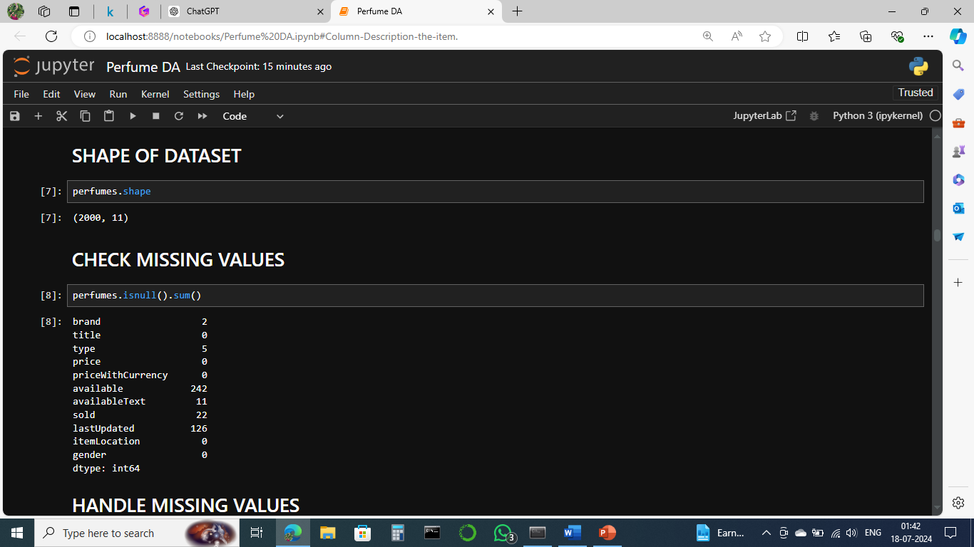

Step 7: Handle missing values and find null values

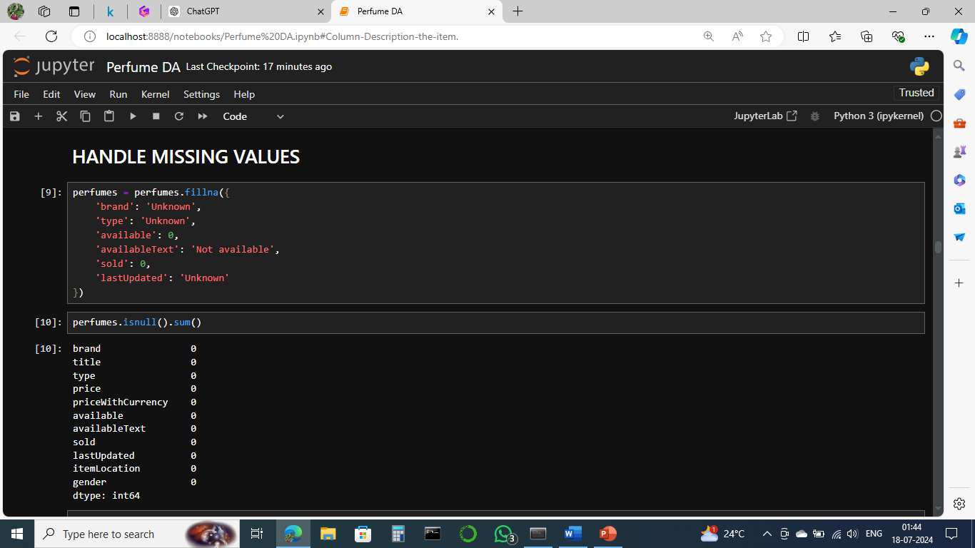

Step 8: Information of data

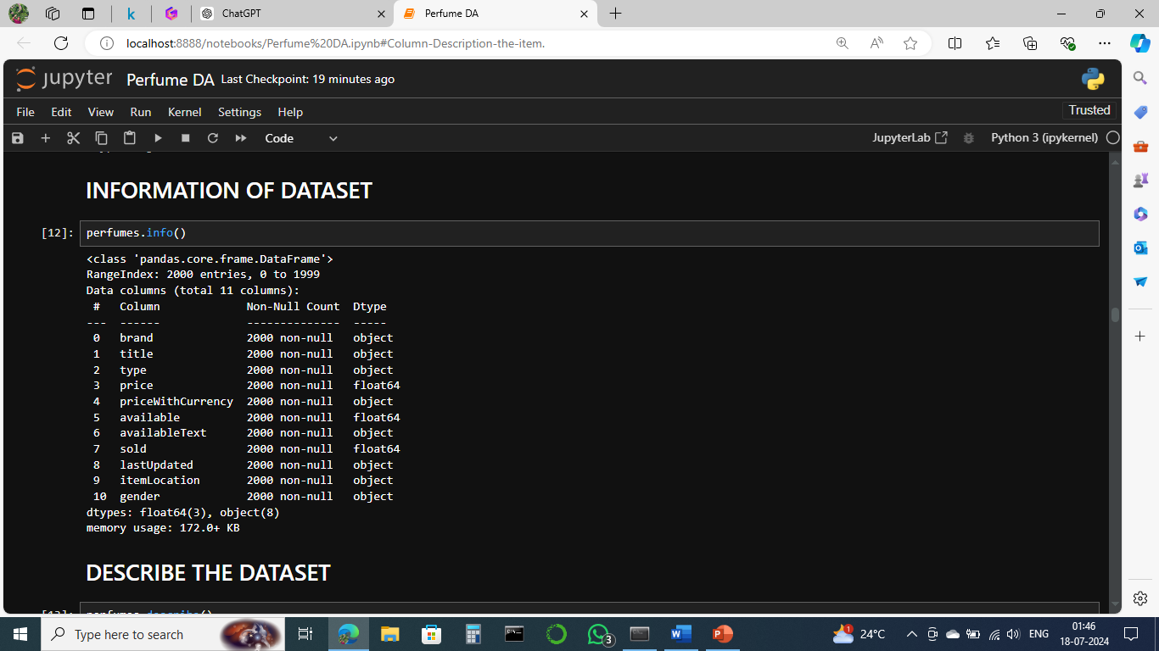

Step 9: Description of data

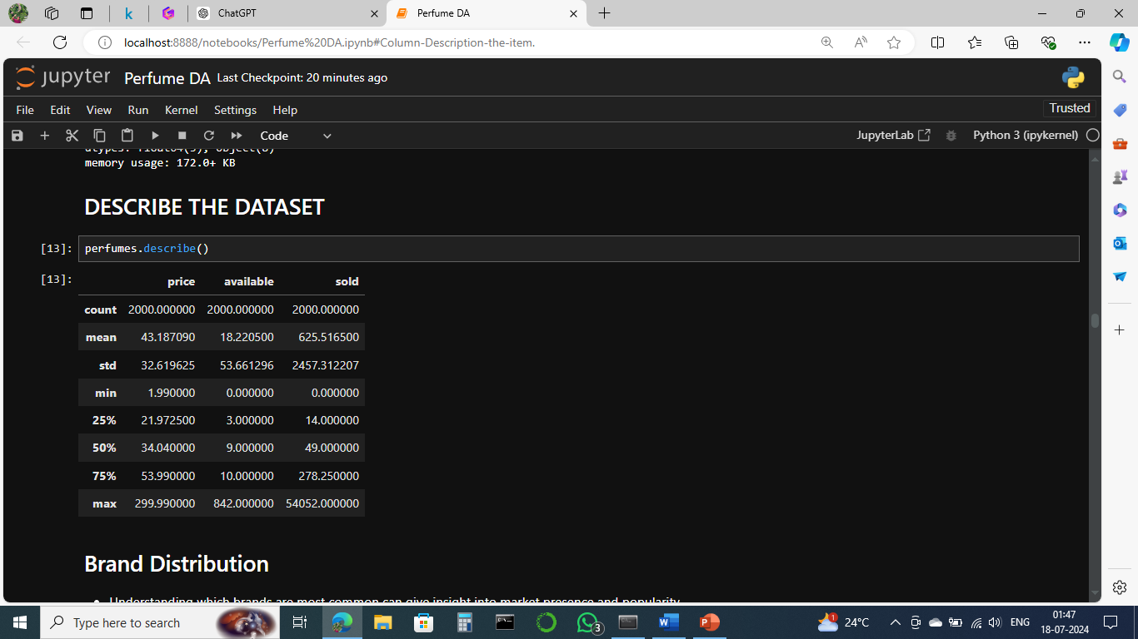

Step 10: Brand distribution

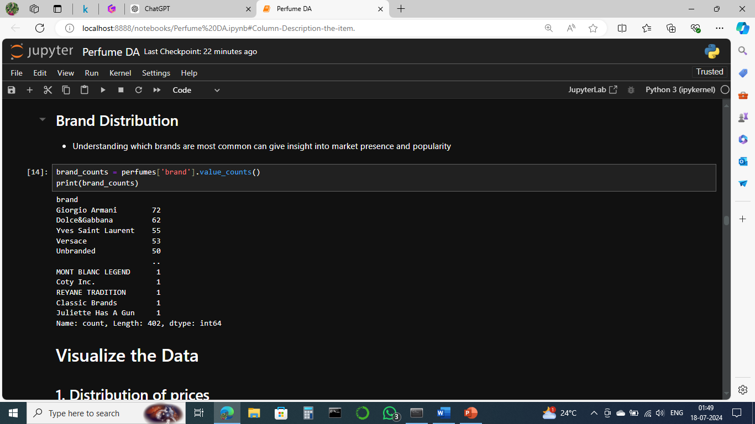

Step 11: Visualize the data

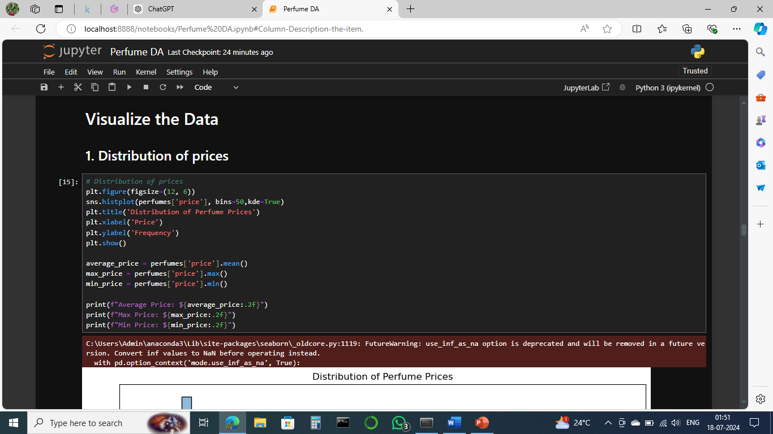

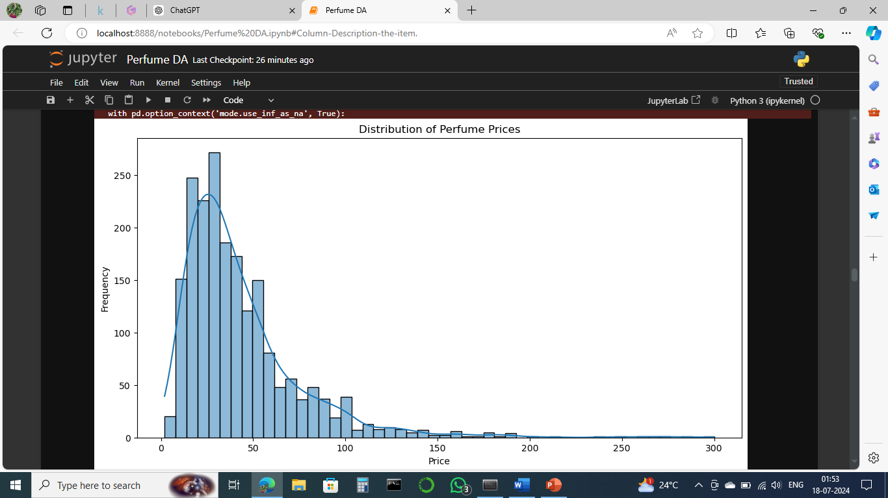

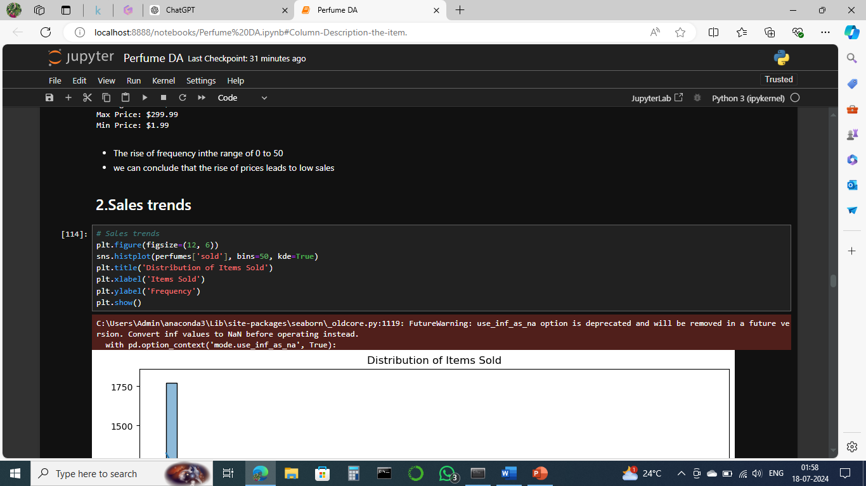

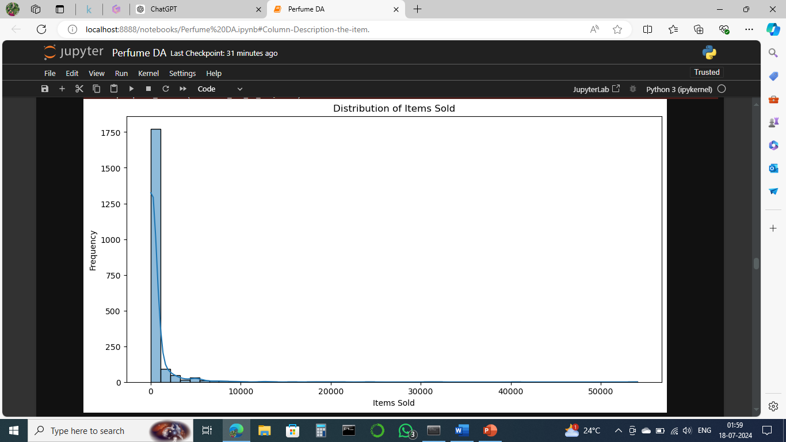

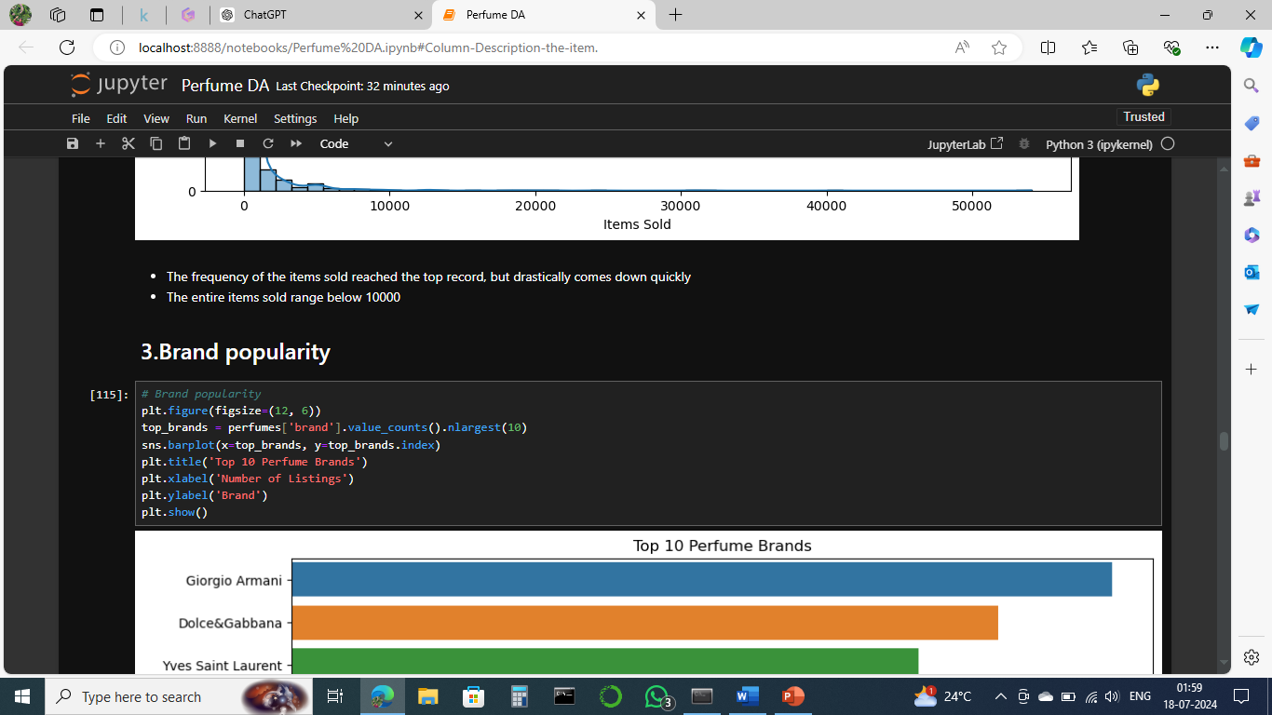

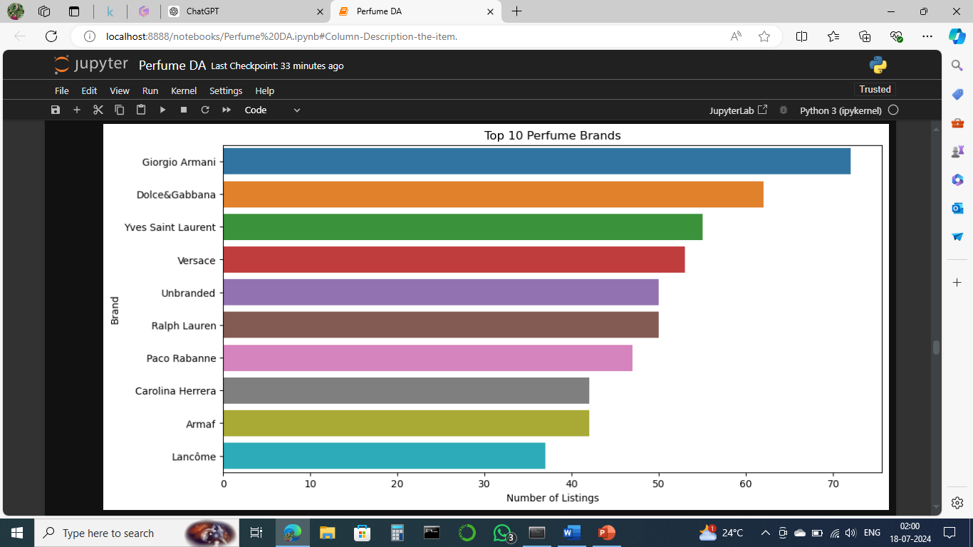

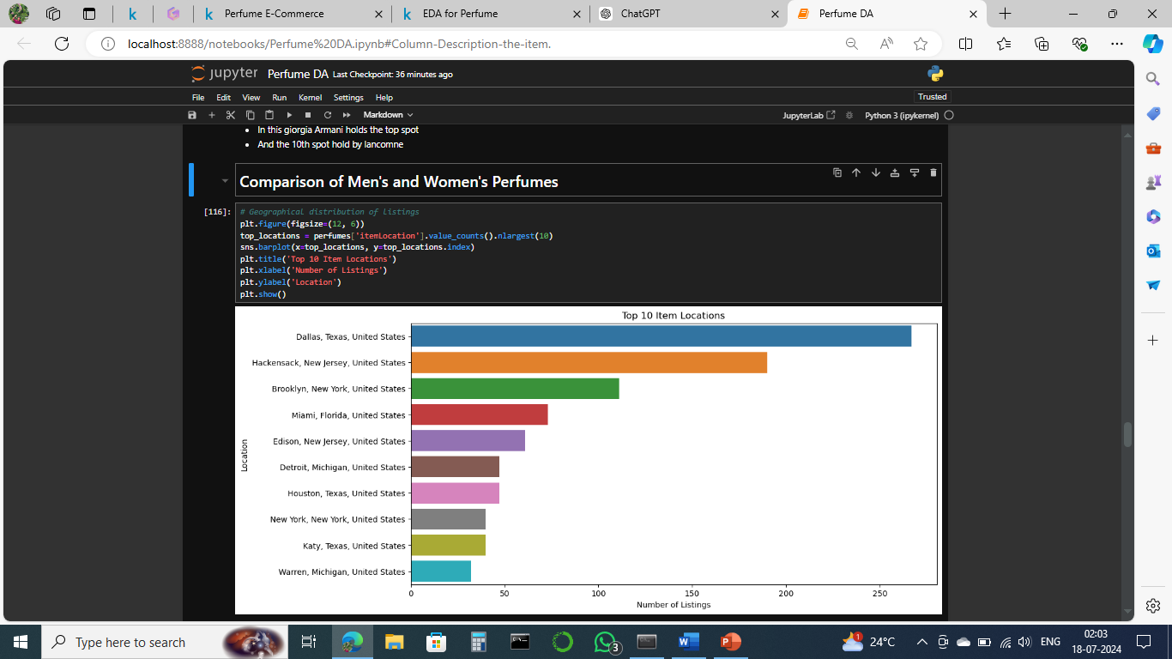

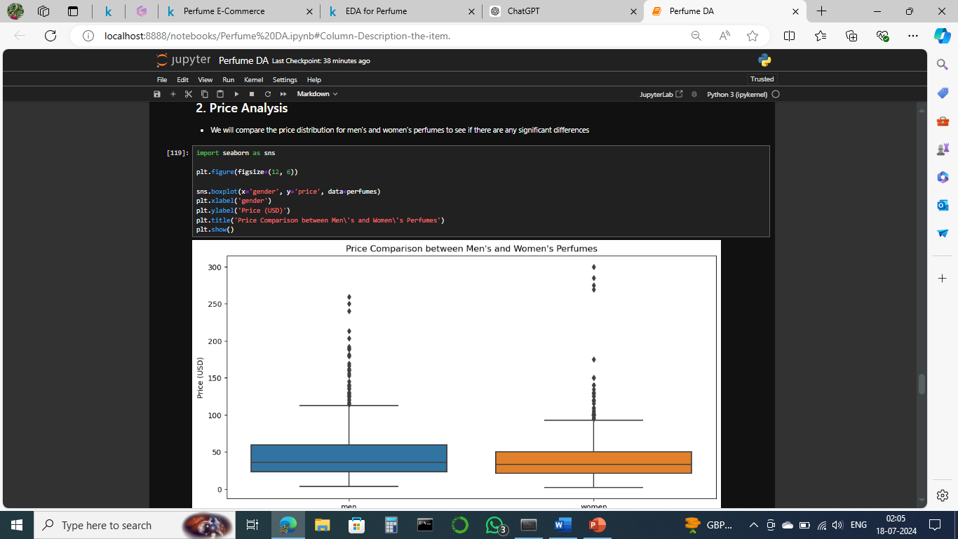

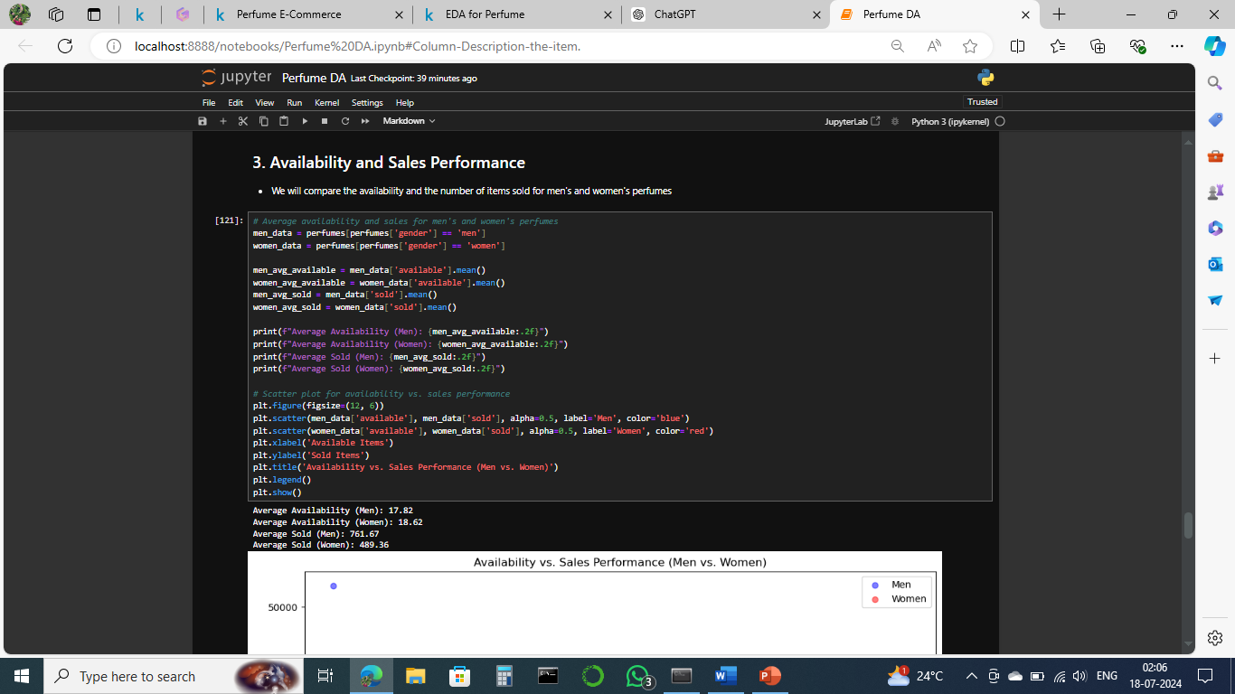

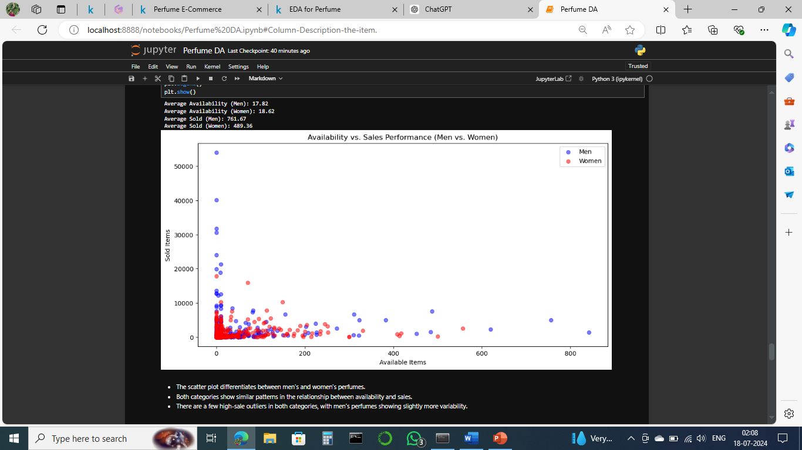

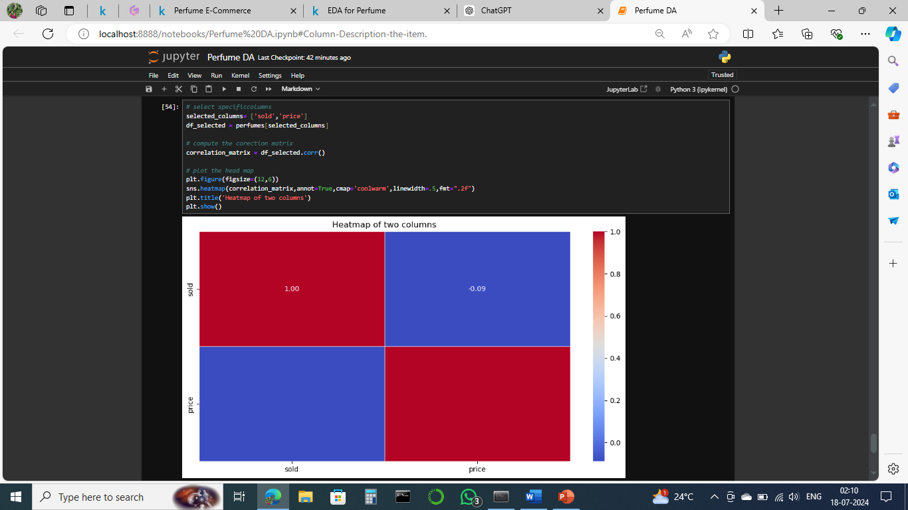

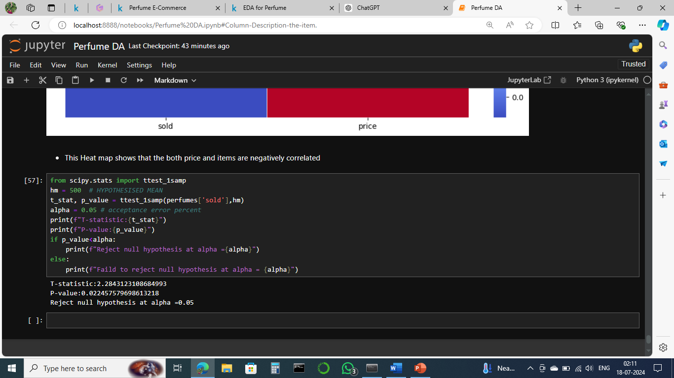

**7. Conclusion:**

In conclusion, the e-commerce perfume business analysis provides valuable insights into customer preferences, market trends, and strategic opportunities for growth. By leveraging data-driven insights and implementing recommended strategies, the business can strengthen its market position, improve customer engagement, and achieve sustainable growth in the competitive e-commerce landscape.

**THANK**

**YOU !**